

ANSWER ARRAY 2


PROGRAM STUDI D-IV TEKNIK INFORMATIKA
JURUSAN TEKNOLOGI INFORMASI
POLITEKNIK NEGERI MALANG
Arranged By:
1. Rajendra Rakha Arya Prabaswara (1941720080/23)

Practicum 1
package Practicum;

public class Praktikum1 {

public static void main(String[] args) {
int[][] value = new int[2][3];

value[0][0] = 12;
value[0][1] = 14;
value[0][2] = 34;
value[1][0] = 30;
value[1][1] = 21;
value[1][2] = 67;

System.out.println(value[0][0] + " " + value[0][1] + " " + value[0][2]);
System.out.println(value[1][0] + " " + value[1][1] + " " + value[1][2]);
}
}

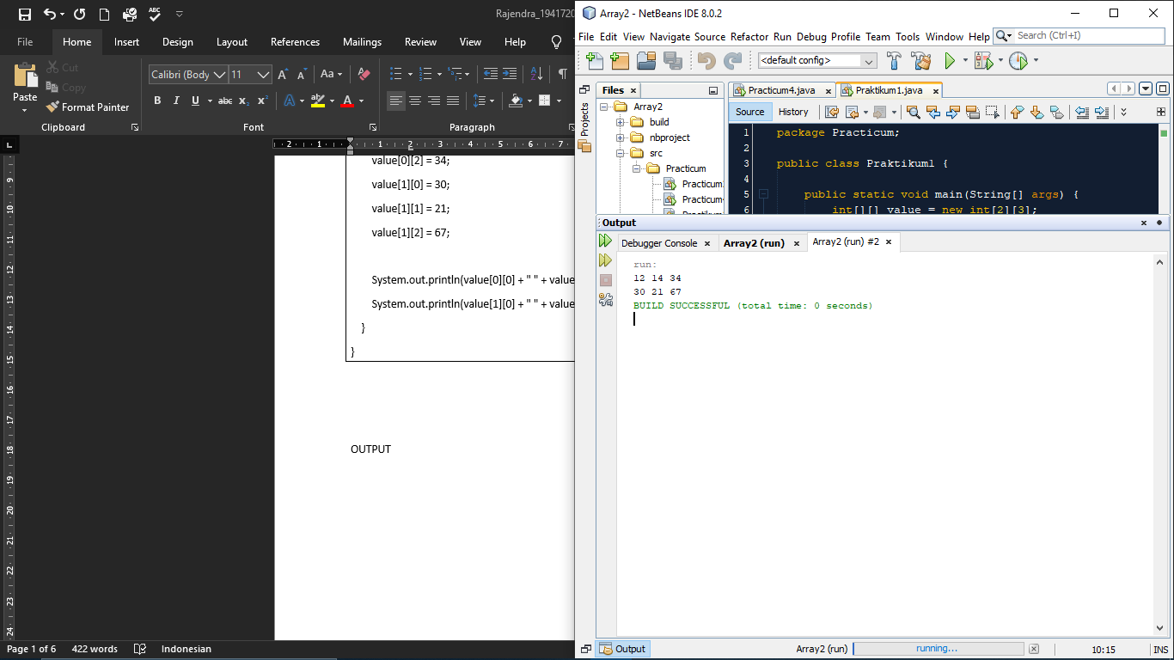

OUTPUT

Practicum 2

package Practicum;
public class Practicum2 {
public static void main (String args []){
int value [][]=new int [2][3];
value [0][0]=12;
value [0][1]=14;
value [0][2]=34;
value [1][0]=30;
value [1][1]=21;
value [1][2]=67;

for (int i=0;i<2;i++){
for (int j=0;j<3;j++){
System.out.print(value[i][j]+" ");
}
System.out.println(" ");
}
}
}

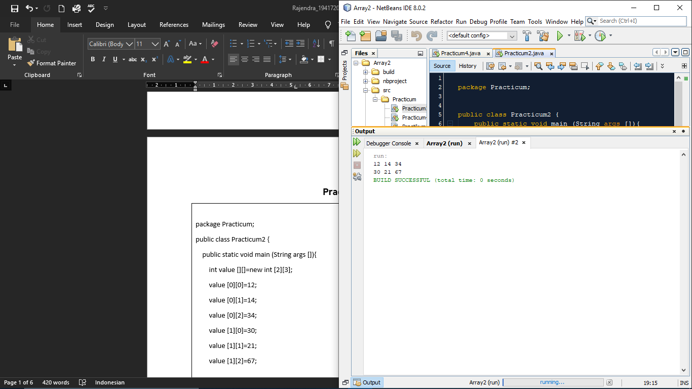

OUTPUT

Practicum 3
FOR
package Practicum;
import java.util.*;
public class Practikum3 {
public static void main(String args[]) {
Scanner sc = new Scanner(System.in);
int value[][] = new int[2][3];

for (int i = 0; i < 2; i++) {
for (int j = 0; j < 3; j++) {
System.out.print("Enter Value number-[" + i + "][" + j + "] ");
value[i][j] = sc.nextInt();
}
System.out.println("------------------------------------");
}
for (int i = 0; i < 2; i++) {
for (int j = 0; j < 3; j++) {
System.out.print(value[i][j] + " ");
}
System.out.println();
}
}
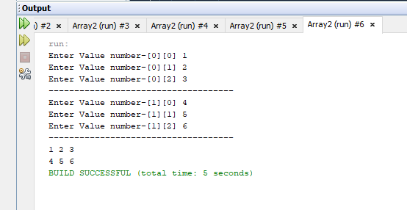
}

OUTPUT

WHILE
package Practicum;
import java.util.*;
public class Practikum3 {
public static void main(String args[]) {
Scanner sc = new Scanner(System.in);
int value[][] = new int[2][3];
int i = 0;
while (i < 2) {
int j = 0;
while (j < 3) {
System.out.print("Enter Value number-[" + i + "][" + j + "] ");
value[i][j] = sc.nextInt();
j++;
}
System.out.println("------------------------------------");
i++;
}
int h = 0;
while (h < 2) {
int k = 0;
while (k < 3) {
System.out.print(value[h][k] + " ");
k++;
}
System.out.println();
h++;
}
}
}

Practicum 4
FOR
package Practicum;
import java.util.*;
public class Practicum4 {
public static void main(String args[]) {
Scanner sc = new Scanner(System.in);
int rowA, columnA;

System.out.print("Enter Row Size of Matrix A: ");
rowA = sc.nextInt();
System.out.print("Enter Column size of Matrix A: ");
columnA = sc.nextInt();
int matrixA[][] = new int[rowA][columnA];
System.out.println("==Input Element Matrix A==");
for (int i = 0; i < rowA; i++) {
for (int j = 0; j < columnA; j++) {
System.out.print("Matrix A[" + i + "][" + j + "]: ");
matrixA[i][j] = sc.nextInt();
}
System.out.println();
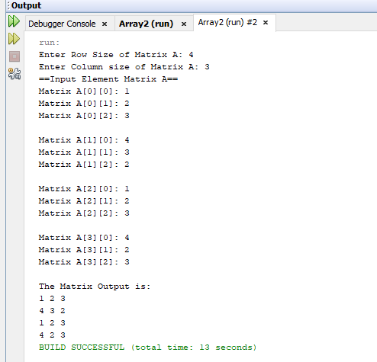
}
System.out.println("The Matrix Output is: ");
for (int i = 0; i < rowA; i++) {
for (int j = 0; j < columnA; j++) {
System.out.print(matrixA[i][j] + " ");
}
System.out.println();
}
}
}
While
package Practicum;
import java.util.*;
public class Practicum4 {
public static void main(String args[]) {
Scanner sc = new Scanner(System.in);
int rowA, columnA;
System.out.print("Enter Row Size of Matrix A: ");
rowA = sc.nextInt();
System.out.print("Enter Column size of Matrix A: ");
columnA = sc.nextInt();
int matrixA[][] = new int[rowA][columnA];
System.out.println("==Input Element Matrix A==");
int i=0;
while (i < rowA) {
int j=0;
while (j < columnA) {
System.out.print("Matrix A[" + i + "][" + j + "]: ");
matrixA[i][j] = sc.nextInt();
j++;
}

System.out.println();
i++;
}
System.out.println("The Matrix Output is: ");
int h=0;
while (h < rowA) {
int k=0;
while (k < columnA) {
System.out.print(matrixA[h][k] + " ");
k++;
}
System.out.println();
h++;
}
}
}

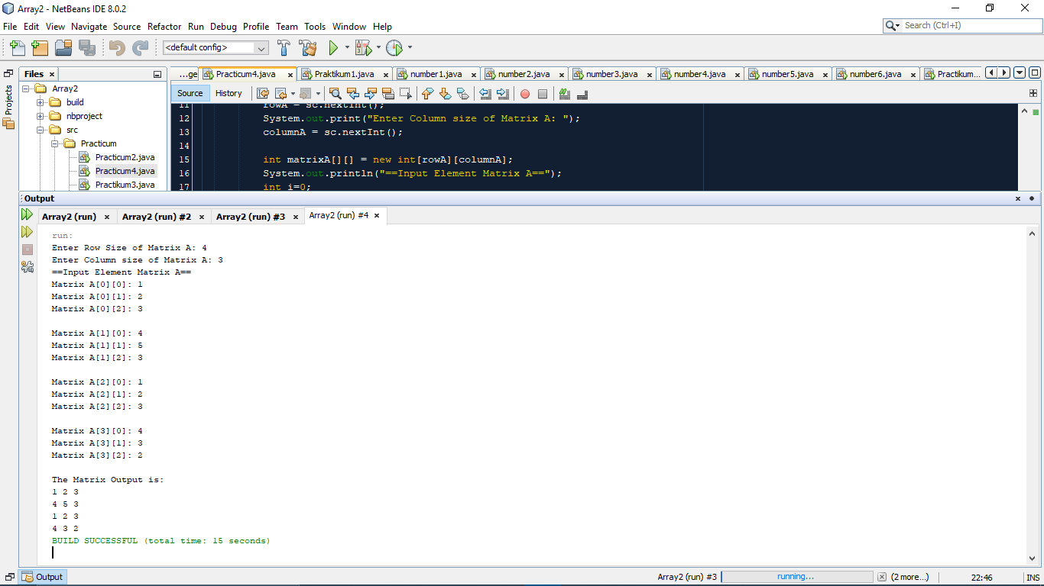
OUTPUT

TASK

package Task;
import java.util.*;
public class number1 {
public static void main(String args[]) {
Scanner sc = new Scanner(System.in);
int[][] array = new int[3][5];
for (int i = 0; i < array.length; i++) {
for (int j = 0; j < array.length; j++) {
System.out.print("input Array baris ke [" + i + "],[" + j + "] :");
array[i][j] = sc.nextInt();
}
}
System.out.println("======================================================");
for (int i = 0; i < array.length; i++) {
for (int j = 0; j < array.length; j++) {
System.out.print(" " + array[i][j] + " ");
}
System.out.println();
}
System.out.println("======================================================");
int max, max1;
for (int i = 0; i < array.length; i++) {
max = 0;
for (int j = 0; j < array.length; j++) {
if (max <= array[i][j]) {
max = array[i][j];
}
}
System.out.println(" Nilai max dari kolom " + i + " adalah " + max);
}
System.out.println("======================================================");
for (int i = 0; i < array.length; i++) {
max1 = 0;
for (int j = 0; j < array.length; j++) {
if (max1 <= array[j][i]) {
max1 = array[j][i];
}
}
System.out.println(" Nilai max dari baris " + i + " adalah " + max1);
}
}
}
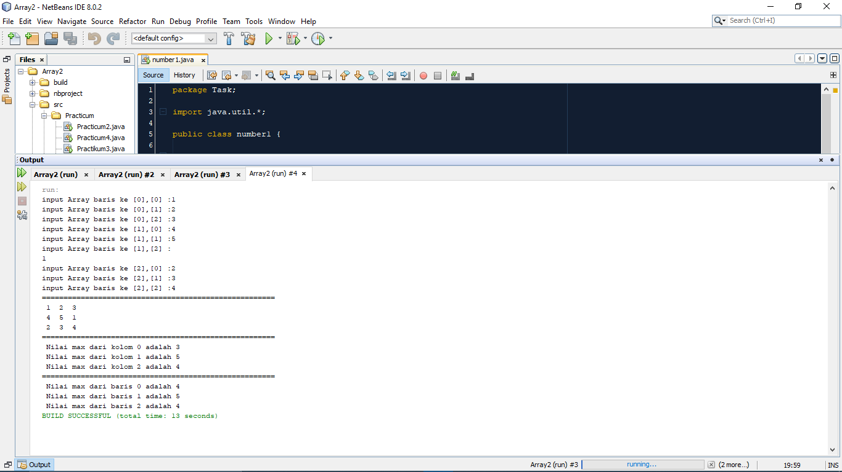

OUTPUT

package Task;
import java.util.*;
public class number2 {
public static void main(String args[]) {
Scanner sc = new Scanner(System.in);
int[][] array1 = new int[3][4];
for (int i = 0; i < 3; i++) {
for (int j = 0; j < 4; j++) {
System.out.print("input Array baris ke ["+ i + "],[" + j + "] :");
array1[i][j] = sc.nextInt();
}
}
System.out.println("Tampilan Array");
for (int i = 0; i < 3; i++) {
for (int j = 0; j < 4; j++) {
System.out.print(" " + array1[i][j] + " ");
}
System.out.println();
}
int sum = 0;
for (int i = 0; i < array1.length; i++) {
for (int j = 0; j < array1[i].length; j++) {
sum = sum + array1[i][j]; OUTPUT
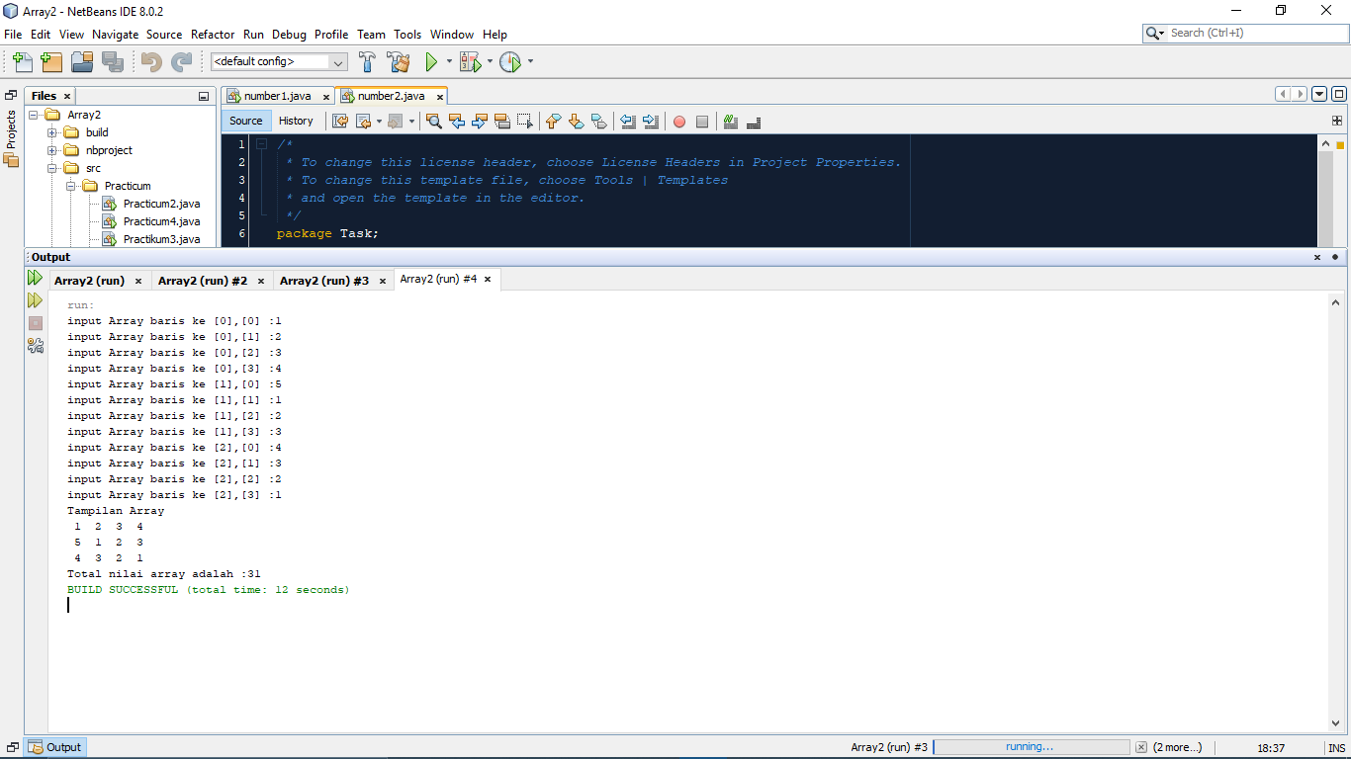
}
}
System.out.println("Total nilai array adalah :" + sum);
}
}

package Task;
import java.util.*;
public class number3 {
public static void main(String args[]) {
Scanner sc = new Scanner(System.in);
int baris, kolom;
System.out.print("Input jumlah baris :");
baris = sc.nextInt();
System.out.print("Input jumlah kolom :");
kolom = sc.nextInt();
int[][] array = new int[baris][kolom];
for (int i = 0; i < baris; i++) {
for (int j = 0; j < kolom; j++) {
System.out.print("Input array baris ke " + i + " kolom ke " + j + " ");
array[i][j] = sc.nextInt();
}
}

System.out.println("Pilih menu");
System.out.println("1. Nilai min");
System.out.println("2. Nilai min dan jumlah");
System.out.println("3. Temukan nilai");
System.out.print("Masukan pilihan ");
int pilih = sc.nextInt();
switch (pilih) {
case 1:
Min(array);
break;

case 2:
Min(array);
Sum(array);
break;

case 3:
Find(array);
break;
}
}
public static void Min(int[][] arr) {
int min = arr[0][0];
for (int i = 0; i < arr.length; i++) {
for (int j = 0; j < arr.length; j++) {
if (arr[i][j] < min) {
min = arr[i][j];
}
}
}
System.out.println("Nilai minimal array : " + min);
}
public static void Sum(int[][] arr) {
int sum = 0;
for (int i = 0; i < arr.length; i++) {
for (int j = 0; j < arr.length; j++) {
sum = sum + arr[i][j];
}
}
System.out.println("Jumlah array : " + sum);
}
public static void Find(int[][] arr) {
Scanner sc = new Scanner(System.in);
int N = 0;
System.out.print("Masukan nilai yang akan dicari :");
int search = sc.nextInt();
for (int i = 0; i < arr.length; i++) {
for (int j = 0; j < arr.length; j++) {
if (arr[i][j] != search) {
N += 1;
} else if (arr[i][j] == search) {
System.out.print("ADA terletak pada index baris " + i + " index kolom ke " + j);
break;
} else if (N == arr.length) {
System.out.print("TIDAK ADA");
}
}
}
}

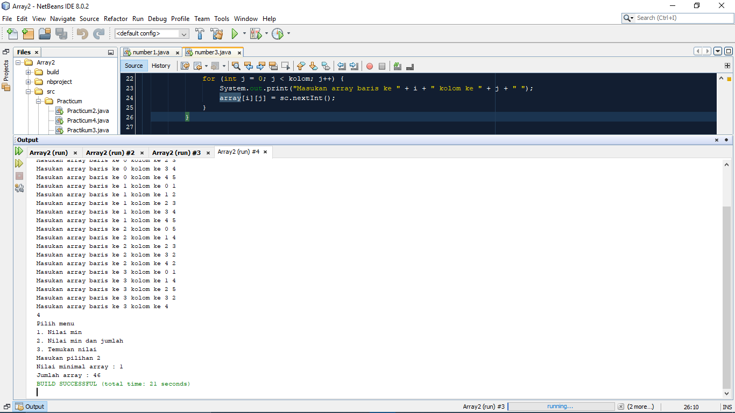
OUTPUT

package Task;
import java.util.*;
public class number4 {
public static void main(String args[]) {
Scanner input = new Scanner(System.in);
int[][] arr = new int[3][5];
int max = 0;
int max1 = 0;
int a = 0;
for (int i = 0; i < arr.length; i++) {
for (int j = 0; j < arr[0].length; j++) {
System.out.print("Masukkan Array Baris [" + i + "] Kolom [" + j + "] : ");
arr[i][j] = input.nextInt();
}
System.out.println("===========================================");
}
for (int i = 0; i < arr.length; i++) {
for (int j = 0; j < arr[0].length; j++) {
System.out.print(arr[i][j] + " ");
}
System.out.println();
}
for (int i = 0; i < arr.length; i++) {
for (int j = 0; j < arr[0].length; j++) {
if (arr[i][j] > max) {
max = arr[i][j];
a = j;
}
}
for (int j = 0; j < arr.length; j++) {
if (arr[j][a] > max1) {
max1 = arr[j][a];
}
}
if (max == max1) {
System.out.println("Nilai terbesar Baris dan Kolom : " + max);
}
max = 0;
max1 = 0;
System.out.println();
}
}
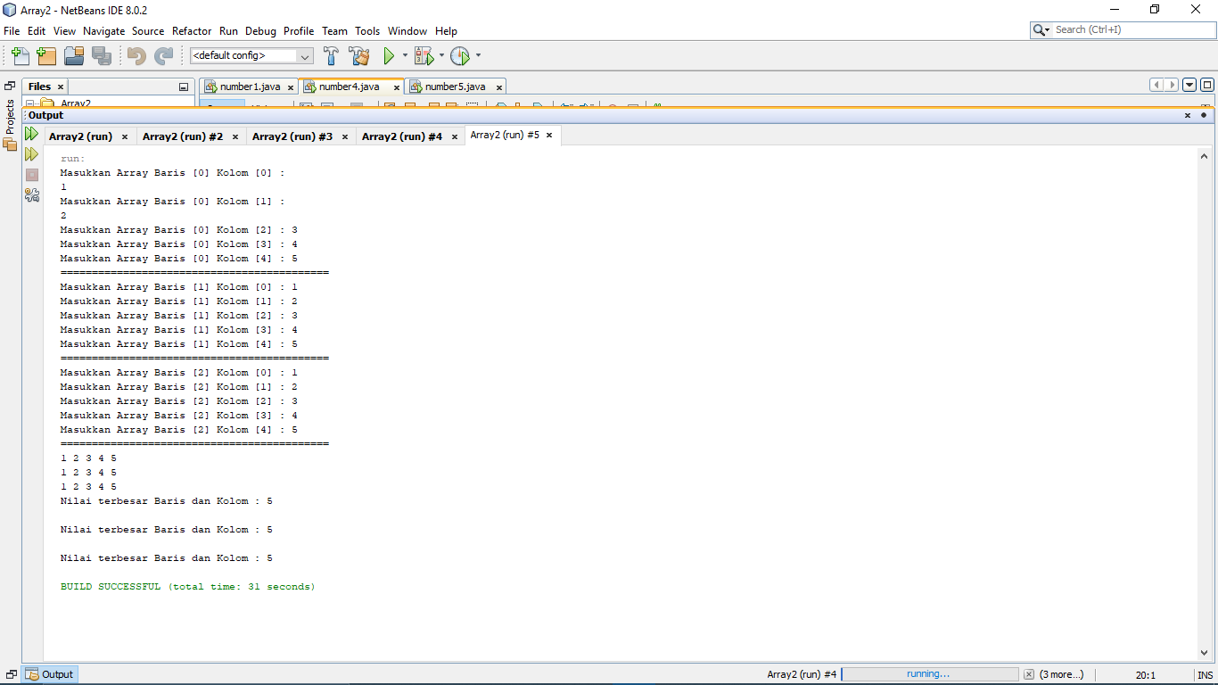
}

OUTPUT

package Task;
import java.util.*;
public class number5 {
public static void main(String args[]) {
Scanner input = new Scanner(System.in);
int x, y;
System.out.print("Input size baris matriks :");
x = input.nextInt();
System.out.print("Input size kolom matriks :");
y = input.nextInt();
int[][] arr = new int[x][y];

System.out.println("Input elemen matriks :");
for (int i = 0; i < x; i++) {
for (int j = 0; j < y; j++) {
System.out.print("Matriks [" + i + "][" + j + "] : ");
arr[i][j] = input.nextInt();
}
System.out.println(“--------------------------------------------“);
System.out.println();
}
System.out.println("Hasil output matriksnya adalah :");
for (int i = 0; i < x; i++) {
for (int j = 0; j < y; j++) {
System.out.print(arr[i][j] + " ");

}
System.out.println();
}
System.out.println("Hasil output matriks transpose adalah :");
for (int i = 0; i < y; i++) {
for (int j = 0; j < x; j++) {
System.out.print(arr[j][i] + " ");

}
System.out.println();
}
}
}

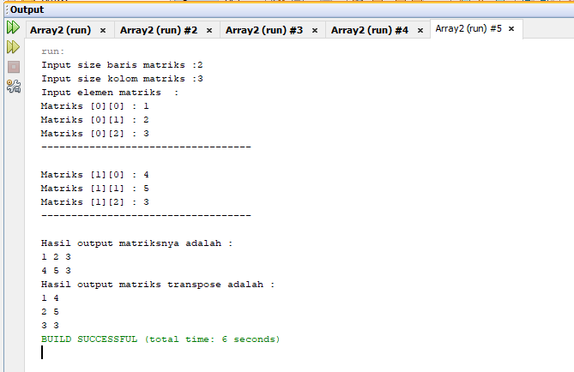
OUTPUT

package Task;
public class number6 {
public static void main(String args[]) {
int a;
char[] kode = {'A', 'B', 'D', 'E', 'F', 'G', 'H', 'L', 'N', 'T'};
String[] Kota = {"BANTEN", "JAKARTA", "BANDUNG", "CIREBON", "BOGOR", "PEKALONGAN", "SEMARANG", "SURABAYA", "MALANG", "TEGAL"};
char[][] kota = new char[10][12];

System.out.println("=====Kode plat Nomor=====");
System.out.println("=========================");
for (a = 0; a < 10; a++) {
kota[a] = Kota[a].toCharArray();
System.out.print(kode[a] + "=");
System.out.println(Kota[a]);
}
System.out.println("=========================");
}
}

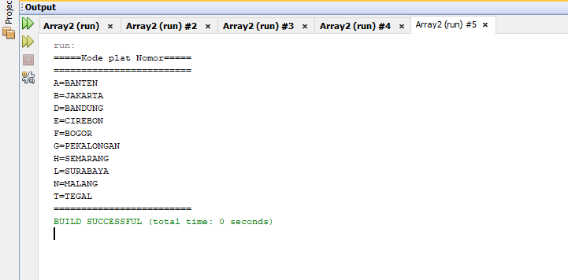

OUTPUT

